Article of the Week #3 Due Date: ___________________Name________________________________
Directions:
1. Mark your confusion.
2. Show evidence of a close reading for SOAPSTone. Mark up the text with questions and/or comments and
connections using active reading strategies(questioning ,predicting, evaluating, clarifying, visualizing)
3. Write a one-page reflection on your own sheet of paper.

Allen HS facility cost $60 million
Edward Almirez, Daily Sports Columnist published in The Dallas Star on September 1, 2012

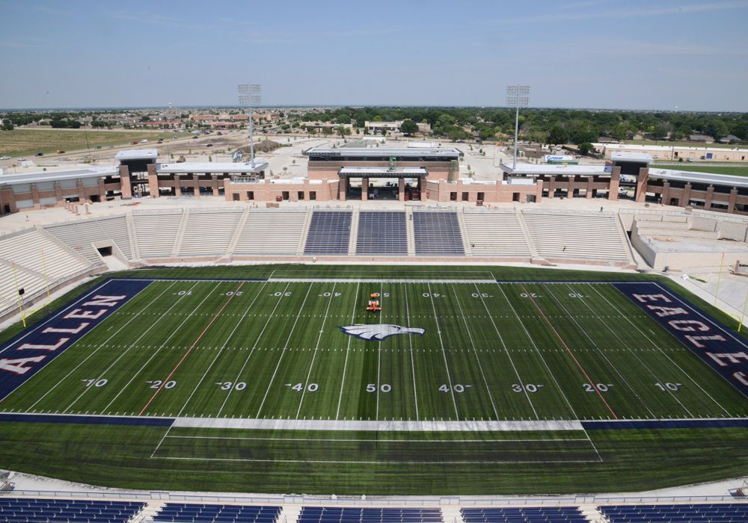
ALLEN, Texas -- Call it the palace of high school football or the Coliseum of the South. "Football is a religion." Or so goes the increasingly overheard statement about our national obsession with the sport. And while tangible verification of this belief can be a bit challenging to come by, a sparkling $60 million temple of sorts offers some very compelling evidence of its accuracy with its seating for 18,000 roaring football fanatics, a 38-foot wide high-definition video screen, corporate sponsors and a towering upper deck with luxury suites for boosters.
Welcome to the new home of Eagles football.
As school districts across the country struggle to retain teachers, replace outdated textbooks and keep class sizes from ballooning, the wealthy, burgeoning Dallas suburb of Allen christened its new stadium in front of a sellout crowd Friday night with a 24-0 victory against defending state champion Southlake Carroll.
In a state that prides itself of having “everything bigger”, Eagle Stadium is the grandest, with a spacious weight room for the players and practice areas for Allen High School's wrestling and golf teams. The school district decided to build it in a down economy, knowing full well it never will recoup the costs. It's a decision that local officials and team supporters defend, saying the stadium will serve as a community centerpiece and source of pride for years to come and will more than pay the costs of operating it.
"There will be kids that come through here that will be able to play on a field that only a few people will ever get the chance to play in," said Wes Bishop, the father of a junior linebacker on the team and head of the local booster club. "In a couple of years, someone's going to do something that's bigger and bigger," said Robert McSpadden, who runs the high school football site TexasBob.com and is one of the premier football boosters in the state of Texas.
For longtime Allen fans, it's a giant step forward from a facility that district spokesman Tim Carroll called "inadequate in almost every way." The old building opened in 1976, when Allen had fewer than 8,000 residents, with 7,000 permanent seats, one concession stand and one set of bathrooms. As the town grew to its population of 87,000, the school had to add portable toilets and rent temporary bleachers, which added 7,000 seats at a cost of $250,000 per year, Carroll said.
Today, the high school has 4,000 students enrolled and a 700-member band that's among the biggest in the country. Collin County, which includes Allen and other Dallas suburbs, is one of the wealthiest areas of Texas -- and home to some of the state's top football teams.
About 63 percent of voters (or more appropriately “worshippers”) supported a $119 million bond package in 2009. Construction on the stadium began a year later. District officials went with more expensive concrete seating over all-aluminum benches, adding perhaps $4 million more to the cost, according to officials. But they said they expected this stadium to last decades. Allen Eagle Stadium's construction continued even as Texas lawmakers cut the state's education funding by $4 billion, reducing all school district tax rates by about one-third in 2006. By the 2011-2012 school year, Allen was facing a $4.5 million budget shortfall and was forced to cut 44 teaching positions and 40 support positions through attrition and voluntary buyouts.
"Our intention is not to recoup the money it cost to build the stadium," Carroll said. "It's not practical to say we'll get that money back. (But) the revenue we receive from the stadium will far exceed the cost of operating it." While the district did not have estimates, Carroll said he expects the stadium to be competitive in hosting high school playoff games and other events. The school has also sold six sponsorships for about $35,000 a year, he said.
The new stadium revives an old argument in Texas about whether communities and their schools have their priorities straight.
Ross Perot, the billionaire businessman and former presidential candidate, repeatedly took aim at his home state's football culture as he pushed the state to shed extracurricular activities and increase accountability measures for academics. "Do we want our kids to win on Friday night on the football field or do we want them to win all through their lives?" Perot said in a 1988 Washington Post column. "That's what we have to start asking ourselves."
Officials in Allen reject the premise that they're focusing on sports over academics. The bonds approved three years ago also funded a new performing arts center, and Carroll said extra revenue from stadium operations will go into the district general fund. Allen's student test scores are also largely stellar.
"Young men and women are now understanding at the age of 8, 9, and 10 that their way to get into a good college or university is by participating in sports and not putting a focus on academics," he said. Allen High principal Steve Payne disagreed.

"We are an exemplary high school," Payne told ABC News. "I think our first class facilities tell everybody that we have first class academics and first class kids. Without them, we wouldn't have those first class facilities." U.S. News and World Report ranked the 5,700-student school 99th out of 1,842 schools in the state of Texas, and 1,219th out of 21,776 schools nationwide. Eighty-five percent of students go on to college, said Payne.
But for now, Eagle Stadium is gaining wide notoriety. The No. 8-ranked Eagles' Friday game against Southlake Carroll, which won a state championship last year and is ranked No. 1 in The Associated Press' Class 5A preseason poll this season, sold out in just more than a day. More than 2,000 people were expected to watch from standing-room areas.
Bishop's son Zack, a linebacker, said he and his teammates already noticed differences: a more spacious weight room, a softer playing field. "It's going to be really incredible to step out in front of a full house and a sold-out game," he said.
Chris Wallace, whose oldest son is a senior quarterback, said she had to reassure him when they visited smaller colleges over the summer with older facilities. "In his mind, this is it," she said. "He can't even believe it's here already."
And there's always room for growth. Fred Montes, one of the architects of what he called "an incredible project," said the district's master plan left open the possibility for more construction, if needed. "The end zone that has seats currently can be expanded," he said. "And on the visitors' side, you can always put a deck."

Possible Reflection Topics:
- In your opinion, do today’s schools (both high school and college) seem to promote athletic success over academic success? Do athletes get preferential treatment in schools?

- Weigh the pros and cons, do you agree with Allen HS’s decision to spend $60 million on a new football stadium?

